20MCA136 – NETWORKING & SYSTEM ADMINISTRATION LAB Dept. of Computer Applications

|  |
| --- |
| **Name: VYSHNAV SURESH**  **Roll No: 56**  **Batch: B**  **Date: 09-05-2022** |

**NETWORKING & SYSTEM ADMINISTRATION LAB**

**Experiment No.: 18**

**Aim**

Write a shell script to find palindrome.

# Program

echo "enter the number"

read num

rev=0 n=$num

while [ $num -gt 0 ] do a=`expr $num % 10` rev=`expr $rev \* 10 + $a` num=`expr $num / 10` done

echo $rev if [ $rev -eq $n]

then

echo "number is palindrome" else

echo " number is not palindrome" fi

# Output screenshot

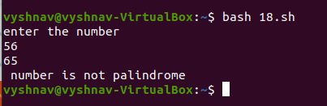

Amal Jyothi College of Engineering, Kanjirappally